**Assignment – 1**

**1. Create the Tables according to the following Definition –**

Table Deposit

ACTNO VARCHAR2(5)

CNAME VARCHAR2(20)

BNAME VARCHAR2(18)

AMOUNT NUMBER(8,2)

ADATE DATE

Table Branch

BNAME VARCHAR2(18)

CITY VARCHAR2(18)

Table Customer

CNAME VARCHAR2(20)

CITY VARCHAR2(18)

Table Borrow

LOANNO VARCHAR2(5)

CNAME VARCHAR2(20)

BNAME VARCHAR2(18)

AMOUNT NUMBER(8,2)

**2. Describe tables which are already created.**

DESC DEPOSIT;

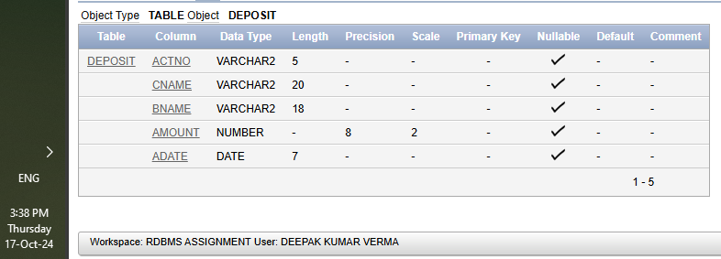

DESC BRANCH;

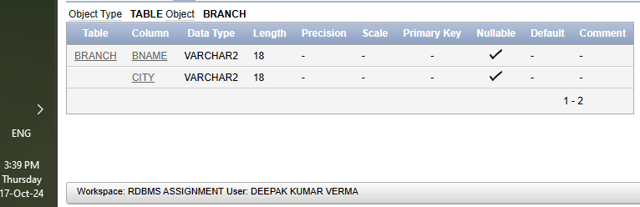

DESC CUSTOMER;

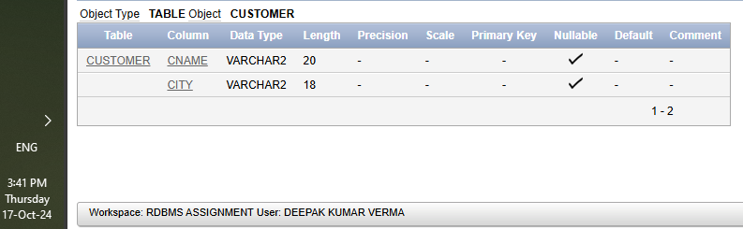

DESC BORROW;

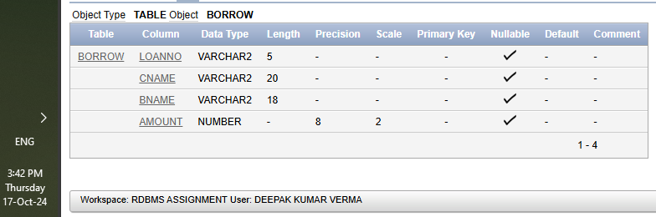

**3. Insert the following Data :**

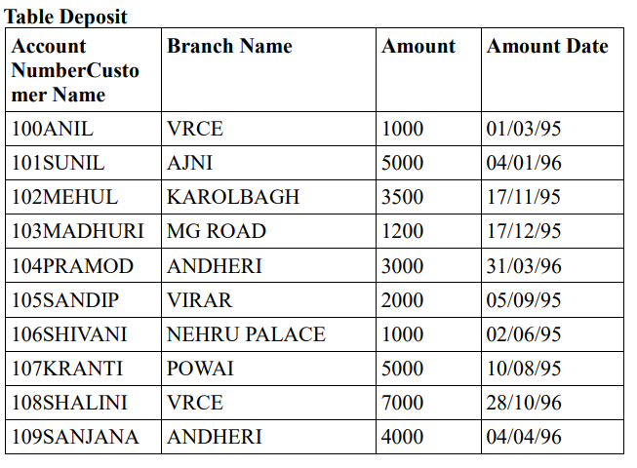

INSERT INTO Deposit (ACTNO, CNAME, BNAME, AMOUNT, ADATE) VALUES ('100', 'ANIL', 'VRCE', 1000, '03/01/1995');

INSERT INTO Deposit (ACTNO, CNAME, BNAME, AMOUNT, ADATE) VALUES ('101', 'SUNIL', 'AJNI', 5000, '01/04/1996');

INSERT INTO Deposit (ACTNO, CNAME, BNAME, AMOUNT, ADATE) VALUES ('102', 'MEHUL', 'KAROLBAGH', 3500, '11/17/1995');

INSERT INTO Deposit (ACTNO, CNAME, BNAME, AMOUNT, ADATE) VALUES ('103', 'MADHURI', 'MG ROAD', 1200, '12/17/1995');

INSERT INTO Deposit (ACTNO, CNAME, BNAME, AMOUNT, ADATE) VALUES ('104', 'PRAMOD', 'ANDHERI', 3000, '03/31/1996');

INSERT INTO Deposit (ACTNO, CNAME, BNAME, AMOUNT, ADATE) VALUES ('105', 'SANDIP', 'VIRAR', 2000, '09/05/1995');

INSERT INTO Deposit (ACTNO, CNAME, BNAME, AMOUNT, ADATE) VALUES ('106', 'SHIVANI', 'NEHRU PALACE', 1000, '06/02/1995');

INSERT INTO Deposit (ACTNO, CNAME, BNAME, AMOUNT, ADATE) VALUES ('107', 'KRANTI', 'POWAI', 5000, '08/10/1995');

INSERT INTO Deposit (ACTNO, CNAME, BNAME, AMOUNT, ADATE) VALUES ('108', 'SHALINI', 'VRCE', 7000, '10/28/1996');

INSERT INTO Deposit (ACTNO, CNAME, BNAME, AMOUNT, ADATE) VALUES ('109', 'SANJANA', 'ANDHERI', 4000, '04/04/1996');

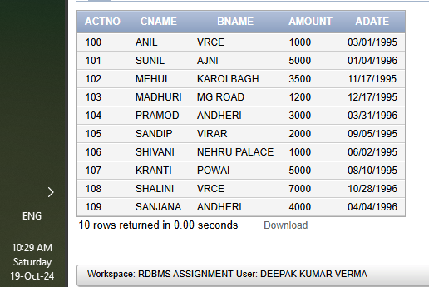

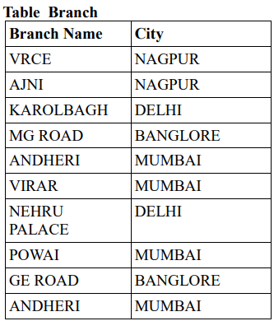

INSERT ALL

INTO Branch (BNAME, CITY) VALUES ('VRCE', 'NAGPUR')

INTO Branch (BNAME, CITY) VALUES ('AJNI', 'NAGPUR')

INTO Branch (BNAME, CITY) VALUES ('KAROLBAGH', 'DELHI')

INTO Branch (BNAME, CITY) VALUES ('MG ROAD', 'BANGLORE')

INTO Branch (BNAME, CITY) VALUES ('ANDHERI', 'MUMBAI')

INTO Branch (BNAME, CITY) VALUES ('VIRAR', 'MUMBAI')

INTO Branch (BNAME, CITY) VALUES ('NEHRU PALACE', 'DELHI')

INTO Branch (BNAME, CITY) VALUES ('POWAI', 'MUMBAI')

INTO Branch (BNAME, CITY) VALUES ('GE ROAD', 'BANGLORE')

INTO Branch (BNAME, CITY) VALUES ('ANDHERI', 'MUMBAI')

SELECT 1 FROM DUAL;

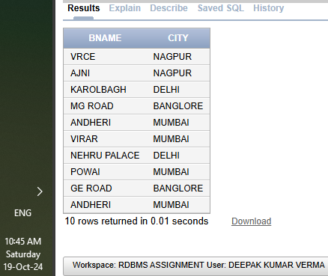

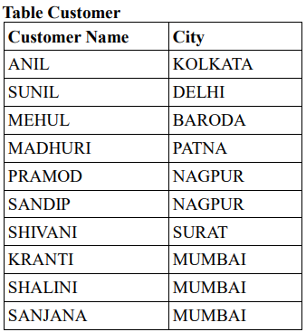

INSERT ALL

INTO Customer (CNAME, CITY) VALUES ('ANIL', 'KOLKATA')

INTO Customer (CNAME, CITY) VALUES ('SUNIL', 'DELHI')

INTO Customer (CNAME, CITY) VALUES ('MEHUL', 'BARODA')

INTO Customer (CNAME, CITY) VALUES ('MADHURI', 'PATNA')

INTO Customer (CNAME, CITY) VALUES ('PRAMOD', 'NAGPUR')

INTO Customer (CNAME, CITY) VALUES ('SANDIP', 'NAGPUR')

INTO Customer (CNAME, CITY) VALUES ('SHIVANI', 'SURAT')

INTO Customer (CNAME, CITY) VALUES ('KRANTI', 'MUMBAI')

INTO Customer (CNAME, CITY) VALUES ('SHALINI', 'MUMBAI')

INTO Customer (CNAME, CITY) VALUES ('SANJANA', 'MUMBAI')

SELECT 1 FROM DUAL;

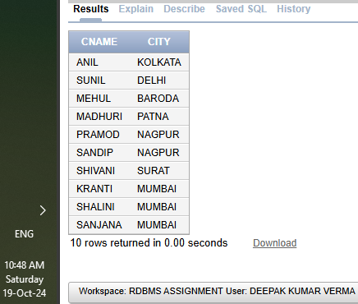

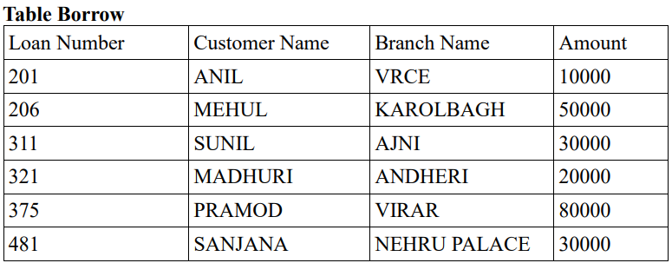

INSERT ALL

INTO Borrow (LOANNO, CNAME, BNAME, AMOUNT) VALUES ('201', 'ANIL', 'VRCE', 10000)

INTO Borrow (LOANNO, CNAME, BNAME, AMOUNT) VALUES ('206', 'MEHUL', 'KAROLBAGH', 50000)

INTO Borrow (LOANNO, CNAME, BNAME, AMOUNT) VALUES ('311', 'SUNIL', 'AJNI', 30000)

INTO Borrow (LOANNO, CNAME, BNAME, AMOUNT) VALUES ('321', 'MADHURI', 'ANDHERI', 20000)

INTO Borrow (LOANNO, CNAME, BNAME, AMOUNT) VALUES ('375', 'PRAMOD', 'VIRAR', 80000)

INTO Borrow (LOANNO, CNAME, BNAME, AMOUNT) VALUES ('481', 'SANJANA', 'NEHRU PALACE', 30000)

SELECT 1 FROM DUAL;

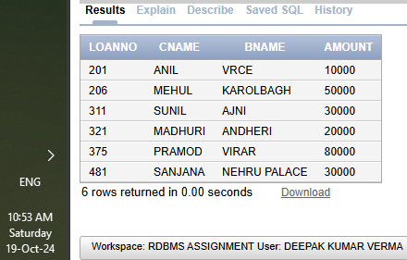

**Assignment – 2**

* List all data from table DEPOSIT -

SELECT *FROM DEPOSIT;

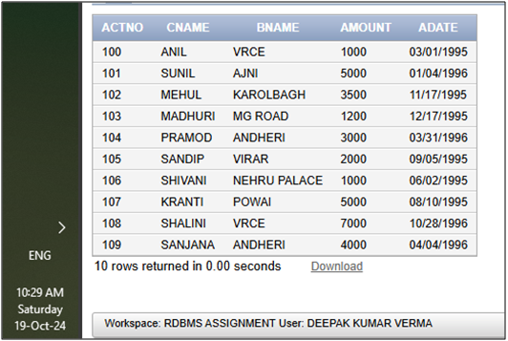

* List all data from table BORROW -

SELECT *FROM BORROW;

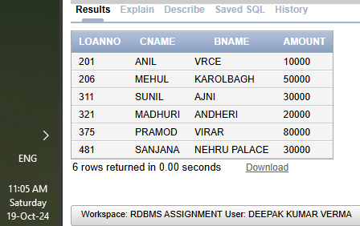

* List all data from table CUSTOMER
* List all data from table BRANCH